**Exercise 4: Creating and Configuring a Maven Project**

**Scenario:**

You need to set up a new Maven project for the library management application and add Spring dependencies.

**Steps:**

1. **Create a New Maven Project:**
   * Create a new Maven project named **LibraryManagement**.

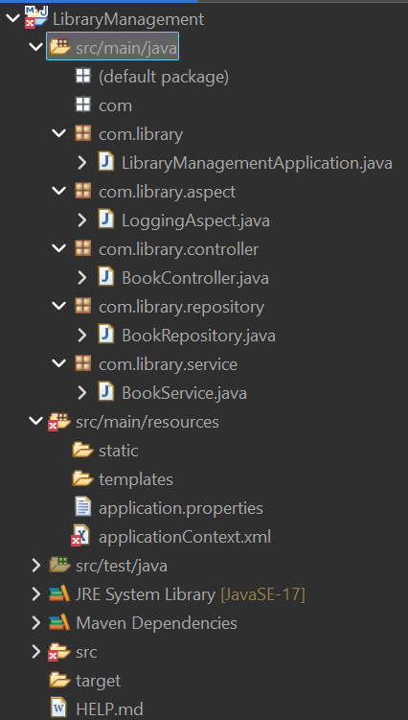

1. **Add Spring Dependencies in pom.xml:**
   * Include dependencies for Spring Context, Spring AOP, and Spring WebMVC.
2. <?xml version="1.0" encoding="UTF-8"?>
3. <project xmlns="http://maven.apache.org/POM/4.0.0" xmlns:xsi="http://www.w3.org/2001/XMLSchema-instance"
4. xsi:schemaLocation="http://maven.apache.org/POM/4.0.0 https://maven.apache.org/xsd/maven-4.0.0.xsd">
5. <modelVersion>4.0.0</modelVersion>
6. <parent>
7. <groupId>org.springframework.boot</groupId>
8. <artifactId>spring-boot-starter-parent</artifactId>
9. <version>3.5.3</version>
10. <relativePath/> <!-- lookup parent from repository -->
11. </parent>
12. <groupId>com.library</groupId>
13. <artifactId>LibraryManagement</artifactId>
14. <version>0.0.1-SNAPSHOT</version>
15. <name>LibraryManagement</name>
16. <description>Demo project for Spring Boot</description>
17. <url/>
18. <licenses>
19. <license/>
20. </licenses>
21. <developers>
22. <developer/>
23. </developers>
24. <scm>
25. <connection/>
26. <developerConnection/>
27. <tag/>
28. <url/>
29. </scm>
30. <properties>
31. <java.version>17</java.version>
32. </properties>
33. <dependencies>
34. <dependency>
35. <groupId>org.springframework.boot</groupId>
36. <artifactId>spring-boot-starter-data-jpa</artifactId>
37. </dependency>
38. <dependency>
39. <groupId>org.springframework.boot</groupId>
40. <artifactId>spring-boot-starter-web</artifactId>
41. </dependency>
42. <dependency>
43. <groupId>org.springframework.boot</groupId>
44. <artifactId>spring-boot-devtools</artifactId>
45. <scope>runtime</scope>
46. <optional>true</optional>
47. </dependency>
48. <dependency>
49. <groupId>com.h2database</groupId>
50. <artifactId>h2</artifactId>
51. <scope>runtime</scope>
52. </dependency>
53. <dependency>
54. <groupId>org.springframework.boot</groupId>
55. <artifactId>spring-boot-starter-test</artifactId>
56. <scope>test</scope>
58. </dependency>
59. <dependency>
60. <groupId>org.springframework.boot</groupId>
61. <artifactId>spring-boot-starter-aop</artifactId>
62. </dependency>
63. </dependencies>
64. <build>
65. <plugins>
66. <plugin>
67. <groupId>org.springframework.boot</groupId>
68. <artifactId>spring-boot-maven-plugin</artifactId>
69. </plugin>
70. </plugins>
71. </build>
72. </project>

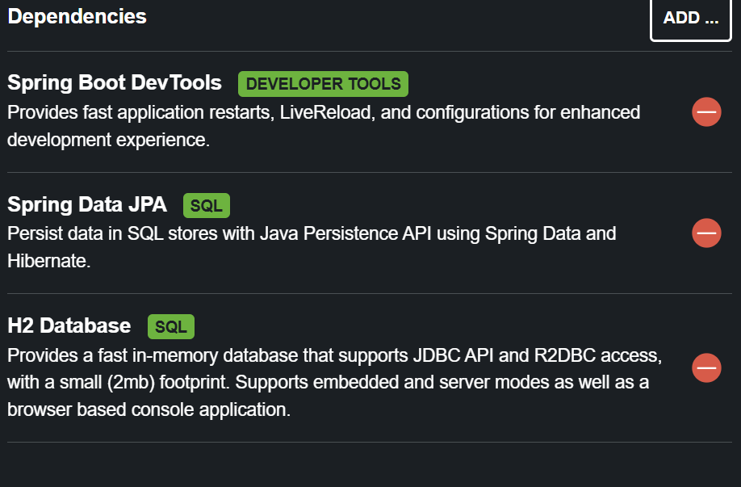

1. **Configure Maven Plugins:**
   * Configure the Maven Compiler Plugin for Java version 1.8 in the pom.xml file.

**localhost:8080**